Anastasija Cumika

Ms. Norton

ENC 1102

2 March 2016

Important Information for Students Must Be Persuasive

Most students at the University of West Florida are required to watch the Academic Integrity video and then take a quiz. Such an activity is necessary so that students are familiar with the rules the UWF Honor Code provides. The information in this video is extremely important, not because students have to take a quiz on it, but because students have to know these rules and what can happen if they break the rules. The reason I decided to perform a rhetorical analysis on this video is that I believe a video that provides such significant information must be persuasive. The Academic Integrity video is very persuasive because it has strong pathos, a technique which grabs the audience’s attention by using a witty humor in the text and funny visuals illustrating the text, along with logos, demonstrated with an astute use of visuals to display a very useful argument to UWF students and with a very well built structure for the text.

The Academic Integrity video can be found on the UWF library website in the section labeled “research help” under the heading “using source ethically.” Although this video is located on the UWF library website, it was made by Joshua Vossler. There is what Vossler says about himself on his website: “I create videos that explain academic concepts using plain language, humorous analogies, and distinctive visuals” (Vossler). Vossler has made about thirty videos for UWF and some more videos for Coastal Carolina University, Santa Fe University of Art & Design, and [Southern Illinois University at Carbondale. These facts establish a very strong ethos for this video. The author made this video for UWF students with the purpose to acquaint them with the rules of academic integrity and to persuade them that these rules are extremely important for the college student to learn. The video itself has simple black and white illustrations and some of the most important words of the text that the author is saying. The content of the text for the video consists of the explanation of what academic integrity means, what academic misconduct is, what the ways of violating the rules of academic integrity are, and what happens if one is accused of academic misconduct.](http://www.lib.siu.edu/)

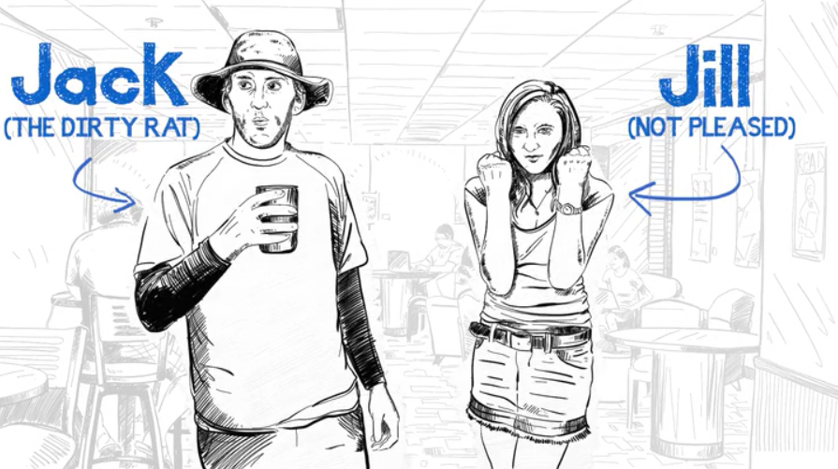 The video itself is very interesting and grabs students’ attention from the first seconds, and there is a reason it is so alluring: strong pathos. Vossler uses very plain and easy language and tells many jokes, and the video is made in a very ingenious way: the author is drawing all the illustrations by himself. Such an approach makes the student feel as if the video was made by a personal friend, and this establishes a very comfortable atmosphere. When one is interested in something, it is easier to remember it, and this video is interesting, so students are more likely to remember the context of the video. Throughout all the video, there are many jokes, but I want to emphasize one part of the video where the author compares academic misconduct with “cheating on your sweetie.” The reason Vossler makes this comparison is that “The rules of academic integrity . . . carry a moral judgment,” which is not like breaking minor laws, such as jaywalking, where “. . . no one’s going to wonder about your moral character.” In that part of the video, the author tells an interesting and funny story about a guy who cheated on his girlfriend, and she told all his 6,000 friends on Facebook about what he did, so “. . . nobody ever trusted him again.” After hearing that story, the viewer feels pretty relaxed and might even forget that this is an important video, not a comedy movie. However, the words following the story explain that this is actually how academic misconduct works: “It sticks with you, even if you transfer to another school.” This device brings the viewer back to the reality, and the student might even feel some emotions of fear.

Another place where the student might feel fear is at the end of the video when Vossler describes what happens if someone accused of academic misconduct is found guilty. On the screen, a giant scheme appears, and the author speaks very fast about that process, so it is hard to follow, but the student understands that this is something very official, and he or she does not want to have to go through such a complex process. After all this description of the process, Vossler again emphasizes the main point: “The file stays with you wherever you go, even if you transfer to another school,” so if any student was still thinking that plagiarism is not a big deal, that student should not have any more doubts about how important that is. Fearful emotions work very persuasively, so the student remembers and understands the most important information from the video, and the main goal of the video is achieved: if the student is afraid, he or she will not break those rules.

Speaking about fearful and humor emotions in this video, I want to mention how these two emotions are working together. The humor eases fear, so that information does not cause student to be too nervous, although it is extremely important. The humor in the video has another role: it mitigates the fearful emotions and helps to shift the focus from that scary information about the aftermath of violating the academic integrity rules to the no less important information about the types of academic misconduct and how to avoid them. Overall, the use of fear together with humor is a great idea to build a persuasive, easy-to-remember, and impressive argument for the student.

Although pathos is a very important part of an argument, Vossler cannot persuade an audience only with emotions; that is why this video has a very strong logos as well. The structure of the text is made in a very smart way. Vossler’s story about the guy who cheated on his girlfriend comes right after a small introduction, and it works as an attention grabber, so the viewer keeps watching the video and really pays attention to it. After the story comes some not very interesting but important information about the types of academic misconduct, but the viewer is already interested in the video and keeps watching it. That information unconsciously sticks in a student’s mind.

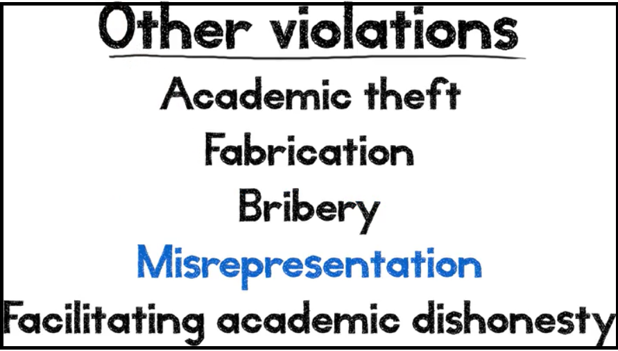Another example of a wise use of the structure is how Vossler emphasizes main points. The most important idea of the video is that if one breaks the academic integrity rules, it sticks with the person forever, and there are two places when author talks about that idea. The first time he mentions it comes right after the story; this is the moment when the video has 100% of the student’s attention, so it is great idea to talk about this point at that moment. Vossler mentions that idea again at the very end of the video, right after a description of the process that is initiated if one is found guilty, and this is again the moment when video grabs a student’s full attention. The fact that the author repeats the main point of the video again at the end works very persuasively because the viewer’s brain realizes that this is important information if it is repeated twice, and the ideas people hear and see last are the ones their brains remember the most.

Vossler’s choice of colors in the video is also significant. Mostly, there are black illustrations on a white background, and this is a good idea because the illustrations must grab one’s attention to the video, so the student keeps watching it, but one must not be too focused on these illustrations, as the most important point is what the author says, not what the author draws. Illustrations are just supporters for an author’s speech that helps the student to stay involved and better remember the context. Vossler also uses blue color for highlighting the words that he is talking about, and blue is a very calm color, so it just helps one to navigate in the video as all the other illustrations do. By using an efficient structure of the text and a smart choice of illustrations and color, Vossler manipulates attention, so he knows where to put the most important information and how to be really persuasive in this video.

Both logos and pathos can be effective separately, but the combinations of these appeals in the video make it extremely persuasive. Working together, both appeals keep the student’s attention throughout all the video, but focus it on what is indeed important. Vossler knows his job and does it very well, and this video is not an exception. His way of delivering important information to students by using a humor is original and very effective. The intended audience of the video is obviously students, mostly freshmen, so humor is the best way of grabbing and keeping those students’ attention because while students might have different interests, everybody loves humor. I am a UWF student, and I want to state that the author did achieve his goal. Before I watched the video, I did not think that plagiarism was a big deal, but now I will not even try to violate the academic integrity rules because it might cost me too much. The author effectively uses pathos to grab and keep students’ attention through humor and persuade them that this information is very important through fear; logos focuses the students’ attention on the most significant points through an appropriate choice of structure and illustrations. Altogether, these appeals make this video very persuasive.

Works Cited

Vossler, Joshua. “Academic Integrity.” Online video clip. *uwf.edu.* UWF library website, 2013-2014. Web. 19 Febr. 2016.

Vossler Joshua. *Joshuavossler.com.* n.d. Web. 24 Feb. 2016.